Kalpa: Overview and User Guide

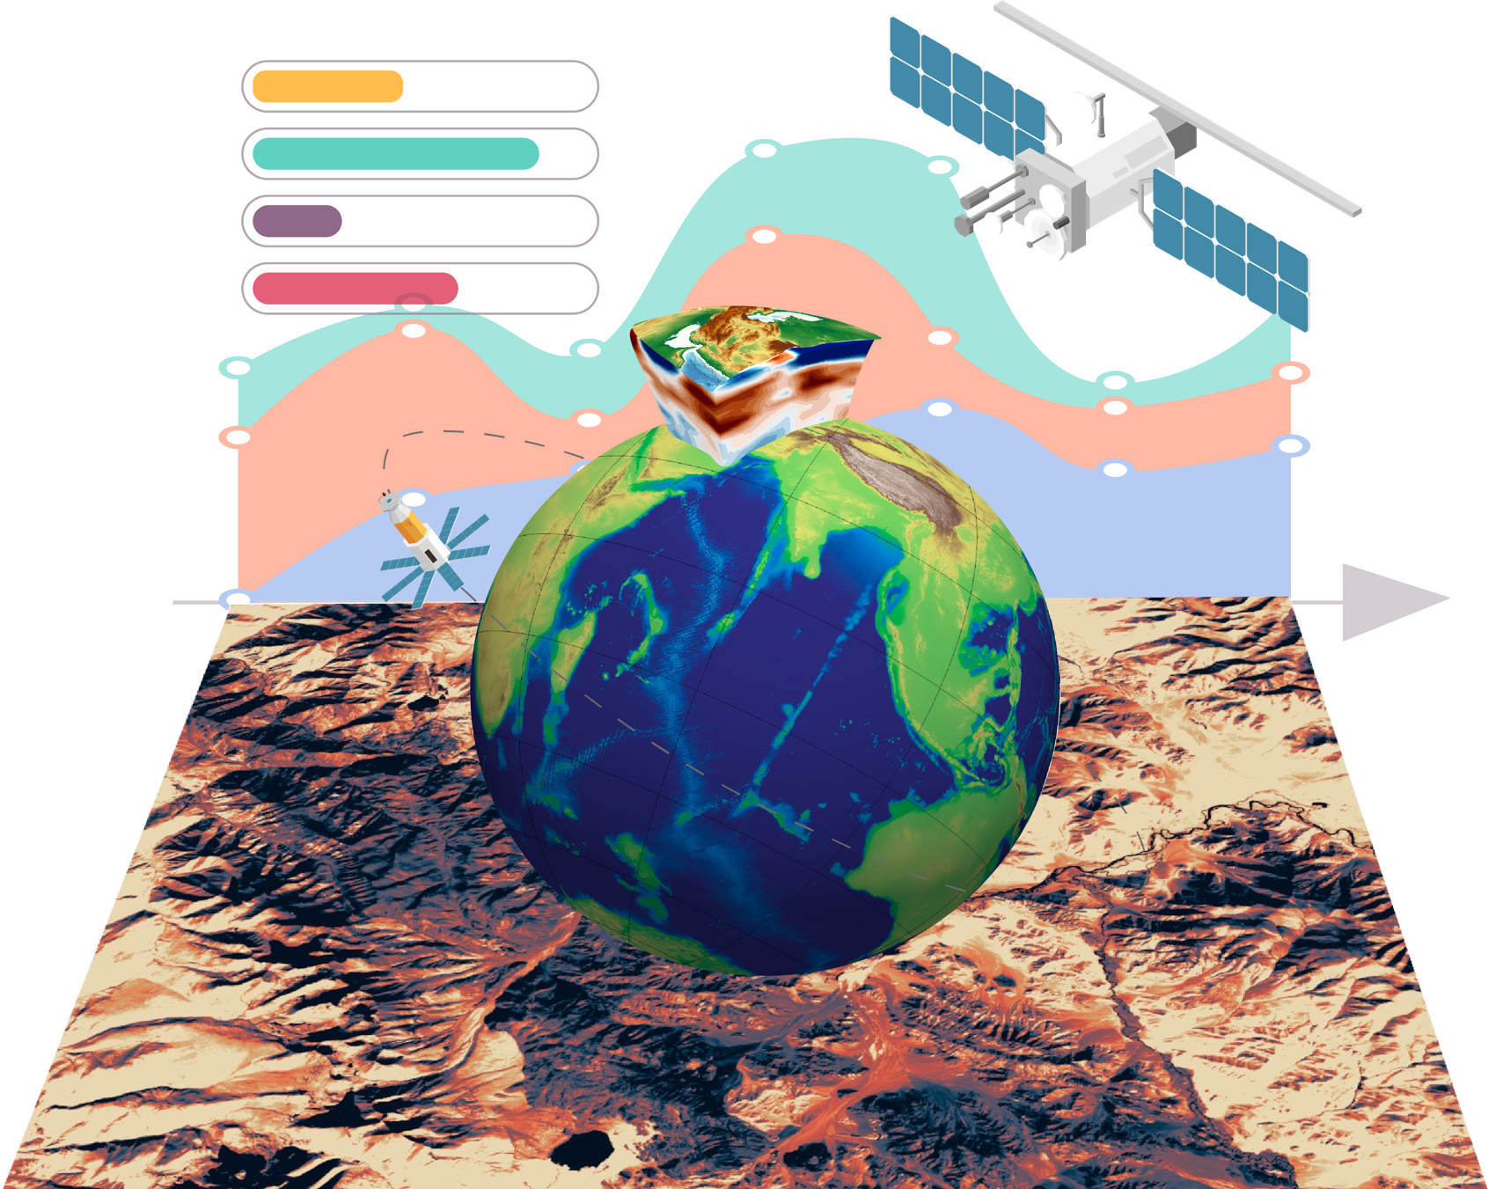

**Satyam Pratap Singh1, Sudhir2, Utpal Singh1**

1. EarthByte Group, School of Geosciences, University of Sydney, NSW, Australia-2006
2. Palvision Labs, Narnaul, Haryana, India-123001

Summary 4

What Can Kalpa Do? 5

Key Advantage 5

Project Management 5

Data Visualization 5

Customization Options 5

Data Processing 6

Machine Learning 6

Utilities 6

Getting Started with Kalpa 7

Installation 7

MacOS Installation Instructions 7

Window Installation Instructions 8

Starting Window 8

1. 3D Cartesian Projection 8

2. 3D Spherical Projection 9

Setting Up the Project Folder 9

The Main Window 9

1. Visualization Window 9

2. Menu Bar 9

3. Axes Tool 9

4. Tool Bar 9

5. Coordinates Display 9

6. RAM Utilization Panel 10

Loading and Visualizing Data 10

Types of Geospatial Data 10

1. Raster Data 10

2. Vector Data 11

Loading and Configuring Raster Data 11

Loading Raster Data 11

Managing Layers 11

Customizing Layer Properties 11

Loading and Configuring Vector Data 12

Loading Vector Data 12

Managing Layers 12

Customizing Layer Properties 12

Future Features 13

Time-Dependent Data 13

Volume Raster Data 13

Time-Dependent Volume Raster 13

Grid Settings and View Controls 13

Grid Settings 13

Default Behavior 13

Customizing the Grid 13

Toggling the Grid 14

Controlling the View 14

Zooming 14

Rotating 14

Repositioning 14

Resetting the View 15

Saving Figures 15

Supported Formats 15

Saving Procedure 15

Creating Data for Geodata Engineering and Artificial Intelligence Modeling 15

Overview 15

Grid Types for Data Sampling 16

1. Random Grid 16

2. Regular Grid 16

Step-by-Step Guide: Sampling Data 16

1. Accessing the Sampling Tool 16

2. Defining the Area of Interest (AOI) 16

3. Selecting Data Layers 17

4. Choosing a Gridding Method 17

5. Creating the Grid and Sampling Data 17

6. Saving the Sampled Data 17

Tips for Effective Data Sampling 17

Filtering Data 18

Vector Filtering 18

Function Overview 18

Examples 19

*9.* *Filtering Rows Based on Multiple Conditions (Advanced)* 20

***10.*** *Filtering Rows Using Custom Functions* 20

*11.* *Filtering Geospatial Data by Attribute and Proximity* 20

*12.* *Filtering Using Logical OR Conditions* 20

13. Filtering by Area or Length Attributes 21

**Tips for Writing Filtering Conditions** 21

Vector Calculator 21

24

Advanced Geophysical and Image Processing Calculations in Kalpa MineX+ 24

Tips for Writing Complex Equations 26

How to apply machine learning in Kalpa? 27

Tutorial 1: Classifying Lithology Types in the Ladakh Region Using Kalpa 28

Dataset Overview 28

Accessing the Dataset 28

Workflow 28

Tutorial 2: Simple Mineral Prospectivity Maps with Kalpa 30

Dataset Overview 30

Workflow 30

Step 3: Sampling Data at Known Deposits 31

Step 4: Creating Unlabeled Data 32

Step 5: Building a Random Forest Classifier 32

Step 6: Building a Prospectivity Model 33

Step 7: Generating Prospectivity Maps 33

# Summary

In the age of big data, artificial intelligence (AI) is transforming earth sciences by enabling efficient analysis of complex datasets and fostering innovative approaches to solve age-old challenges. Kalpa, a Python-based geospatial software, represents a pioneering step in this direction. Built with versatility at its core, Kalpa seamlessly integrates AI and machine learning workflows into geoscience applications, offering unparalleled customization through its Python plugin architecture. Kalpa's capabilities span advanced 3D visualization, geospatial data processing, and machine learning model development. It supports global and regional raster and vector datasets, allowing for interactive analysis in both spherical and cartesian coordinates. With tools to process satellite imagery, geological and geophysical data, unmanned aerial vehicle (UAV) data, and digital geological maps, Kalpa caters to a wide range of disciplines, from mineral exploration to natural hazard prediction. Its machine learning integration supports supervised and unsupervised algorithms for applications such as paleotopography reconstruction, mineral prospectivity mapping, city planning, agricultural productivity optimization and natural hazard mapping. Designed with an intuitive interface and robust export features for publication-ready outputs, Kalpa bridges the gap between domain-specific expertise and cutting-edge AI methodologies. By empowering earth scientists, environmental researchers, and GIS professionals to analyze, model, and predict with precision, Kalpa sets a new frontier in the application of artificial intelligence to earth sciences.

# What Can Kalpa Do?

Kalpa is a powerful and versatile software suite designed to cater to the needs of professionals in geology, GIS, and related fields. Leveraging advanced visualization and processing capabilities, Kalpa bridges the gap between geospatial data and actionable insights. Here's what Kalpa offers:

### Key Advantage

One of Kalpa's biggest advantages is that it is written in Python. This enables seamless integration of any Python script as a plugin, making it especially suitable for machine learning workflows and custom geospatial data processing tasks.

### Project Management

* **Project Creation**: Easily create and manage projects in a specific folder location to keep your work organized.

### Data Visualization

Kalpa supports loading and visualizing global and regional raster and vector data in both 3D spherical and cartesian coordinates using the robust VTK backend.

#### Raster Data Visualization

* **Supported Formats**: Visualize raster data from diverse sources, including:
  + Satellite Imagery: Sentinel-2, Landsat (5, 7, 8), ASTER, Hyperion, WorldView-3, AVIRIS, and HyMap.
  + UAV Data: UAV imagery for lithological and structural analysis.
  + Geophysical Models: Topography, crustal and lithospheric thickness, seismic tomography, Geodynamics model etc.
* **Export Options**: Generate publication-ready figures in formats such as .svg, .eps, .ps, .pdf, .tex, .png, .jpeg, and .jpg.

#### Vector Data Visualization

* **Supported Formats**: Load and visualize vector data in shapefile and GPKG formats, including points, lines, and polygons.
* **Applications**: Geological maps, geochemical data, structural data, lithological maps, and more.

### Customization Options

* **Raster Layers**:
  + Adjust color maps using over 50 scientific colormaps for enhanced data interpretation.
* **Vector Layers**:
  + Visualize specific vector data columns with custom settings for size, width, opacity, fill, and color.
  + Apply scalar data visualization using scientific colormaps.
* **Grid Settings**:
  + Add latitude and longitude grids with customizable size, width, opacity, and color to create publication-ready visuals.

### Data Processing

#### Data Sampling

* Extract raster and vector data within a specified area of interest, shapefile, or bounding region to create machine-trainable datasets for geospatial machine learning, geostatistics, and modeling.
* Generate grids for sampling:
  + **Random Grid**: Define a specified number of points.
  + **Regular Grid**: Set a specific resolution.
* Perform operations:
  + Sample raster data onto grids.
  + Sample specific vector data columns and calculate distances to nearby vector features.

#### GIS-Style Vector Processing

* **Merge Layers**: Combine multiple vector layers row-wise or column-wise.
* **Bounding Box Creation**: Generate bounding box layers from raster or vector data for sampling.
* **Data Filtering**: Apply Python-style conditions to filter geospatial data.
* **Calculator Tool**:
  + Perform Python-style calculations on layers for diverse applications:
    - **Satellite Data**: Calculate band ratios and remote sensing indices.
    - **Geophysical Data**: Apply complex potential field filters.
    - **Image Processing**: Develop filters for structural analysis, fault mapping, and more.

### Machine Learning

Kalpa integrates cutting-edge machine learning models to support supervised and unsupervised tasks:

* **Supported Models**:
  + Random Forest Regressor and Classifier.
  + Positive Labeled Enabled Bagging (PU-enabled RF).
  + K-means Clustering and DBSCAN.
  + More models coming soon
* **Applications**:
  + **Geological Insights**:
    - Predict paleotopography, crustal thickness, and lithosphere thickness.
  + **Mineral Exploration**:
    - Analyze lithological units, alteration types, and mineral distributions.
    - Create prospectivity maps of minerals such as Cu, Au, Pb, Zn, and Fe.
  + **Natural Hazards**:
    - Predict landslides, floods, and forest fires.
  + **Agriculture**:
    - Enhance agricultural productivity using geospatial data.
* **Model Sharing**:
  + Save trained models for reuse and share them with others.
  + Apply trained models to new regions for insights.

### Utilities

* **Resource Monitoring**: Display current RAM utilization.
* **Coordinate Tracking**: View precise coordinates of the cursor.

Kalpa is not just a tool; it is your gateway to unlocking the full potential of geospatial data. Whether you are an ArcGIS or QGIS user or exploring geospatial data for the first time, Kalpa equips you with the features and flexibility to achieve your goals effortlessly.

# 

# Getting Started with Kalpa

Welcome to **Kalpa**, a versatile software suite for geospatial data visualization, processing, and machine learning. This guide will walk you through the initial setup and introduce you to the main features of the interface.

## Installation

### MacOS Installation Instructions

1. **Download:** Obtain the latest .dmg file for Kalpa from the official download link.
2. **Install:** Drag and drop the .dmg file into the Applications folder.

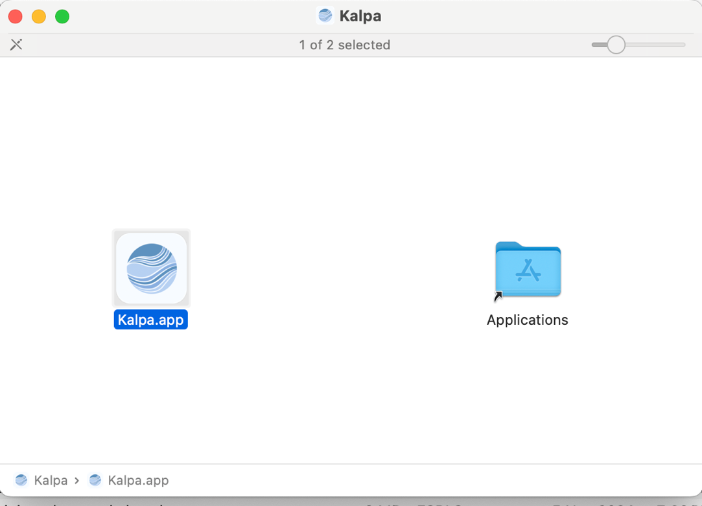

1. **Launch:** Open Kalpa from Launchpad. Upon successful loading, the starting window of Kalpa will appear.

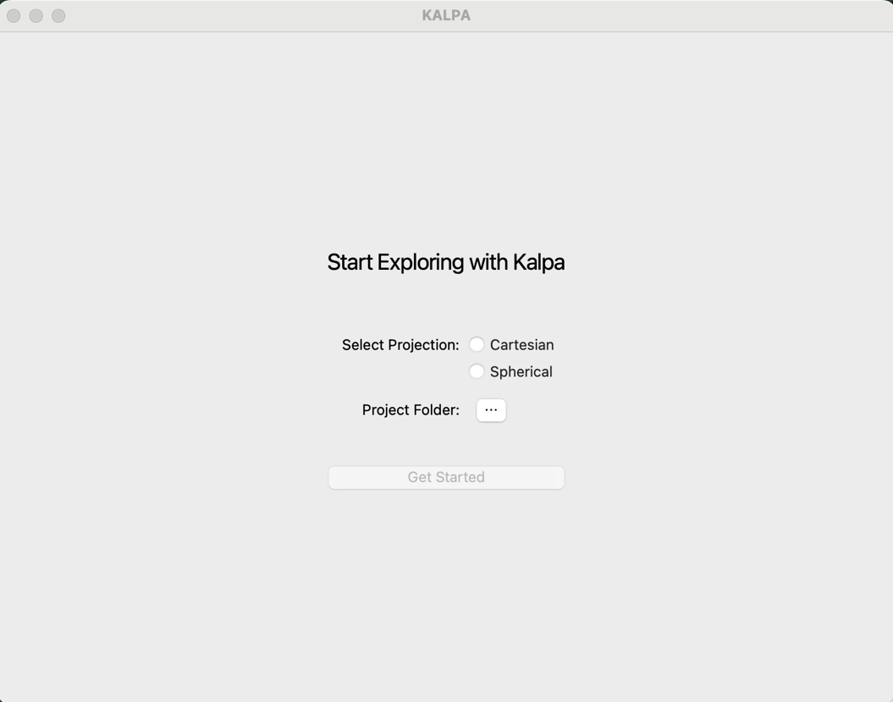

### Window Installation Instructions

1. **Download**: The latest setup file (.exe) from the official link.
2. Install: Double click to start installation. Click Next. Select the folder to want save the installation. Check yes for desktop setup. It will take few minute to finish the setup.

## Starting Window

When you launch Kalpa, you’ll be greeted by the **Starting Window**, which prompts you to **Select Projection**.



Kalpa supports two types of projections:

### 1. **3D Cartesian Projection**

* This projection allows you to visualize data on a flat Cartesian plane.
* Surface raster and vector data are placed at a reference plane set 6,371,000 meters (the approximate radius of the Earth) from the Earth's center.
* This setup is particularly useful for analyzing **global** and **regional datasets**, especially when working with volumetric rasters.

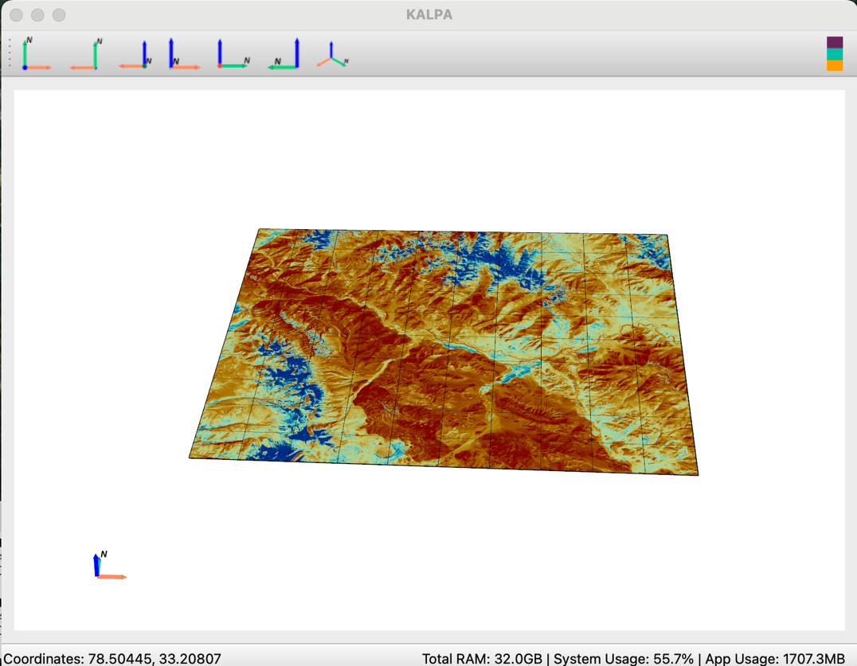

### 2. **3D Spherical Projection**

* This option lets you visualize raster and vector data in a spherical projection.
* It is ideal for datasets with a **global extent**, enabling a more natural representation of Earth's surface curvature.

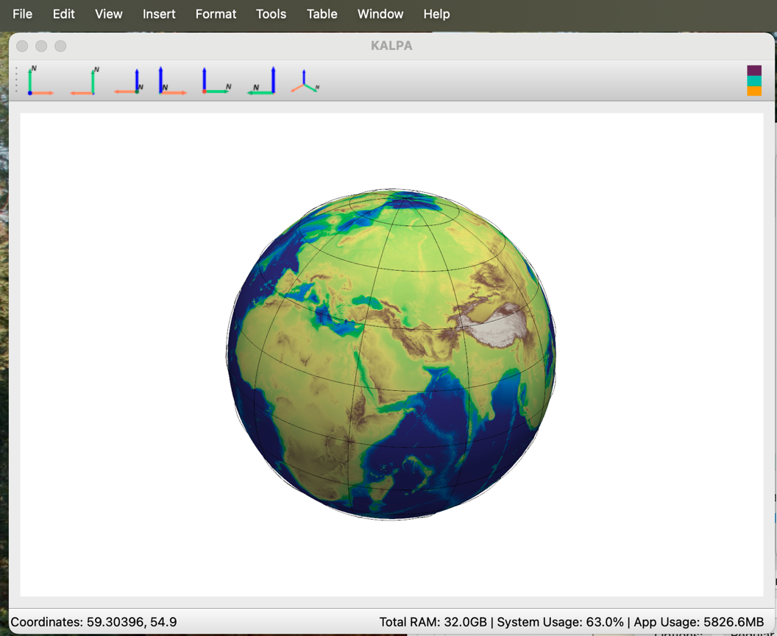

### Setting Up the Project Folder

* In the Starting Window, you’ll also set up your **Project Folder**. This is where all intermediate outputs, including data files, figures, models, and legends, are automatically saved.
* If you plan to work with **high-resolution** or **large datasets**, consider setting this folder on an external hard drive to manage storage efficiently.



## The Main Window

Once you’ve set up the projection and project folder, you’ll enter the **Main Window**, the central workspace in Kalpa.

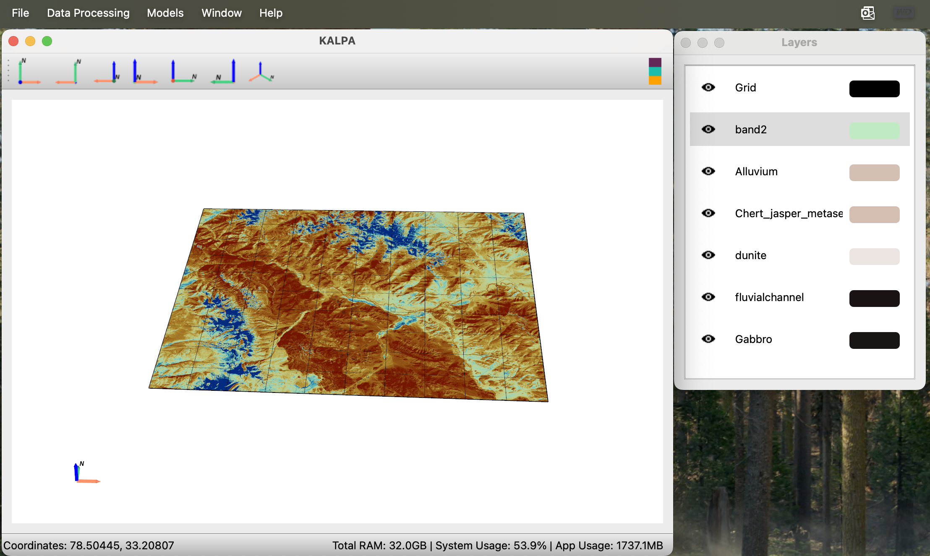

6

5

1

3

4

2

Here’s a quick overview of its components:

### 1. **Visualization Window**

* This is where your loaded data is displayed.
* You can control the camera view by repositioning, rotating, and zooming.

### 2. **Menu Bar**

* The menu bar provides access to various options, such as loading data, processing tools, and applying workflows.

### 3. **Axes Tool**

* This interactive tool shows the current orientation of the camera and allows you to adjust it directly.

### 4. **Tool Bar**

* Quickly change the camera's position along different axes using the toolbar.

### 5. **Coordinates Display**

* Displays the current coordinates of the mouse pointer in the active projection. Visualise legend layer legends.

### 6. **RAM Utilization Panel**

* Provides a live view of the total, system, and application RAM usage, helping you monitor resource consumption.

By now, you should have a good understanding of Kalpa's starting and main windows. In the next chapter, we’ll dive deeper into loading data and configuring layers for visualization.

# Loading and Visualizing Data

Kalpa is designed to handle and visualize various types of geospatial data. This chapter provides an overview of the supported data formats, loading instructions, and customization options to optimize your workflow.

## Types of Geospatial Data

Kalpa primarily supports two types of geospatial data:

### 1. **Raster Data**

Raster data represents information as a grid of values. Each pixel in the grid corresponds to a specific geographic location and contains a value representing a characteristic of that location (e.g., elevation, temperature, or satellite imagery).

* **Continuous Raster Data:** Values vary smoothly across space (e.g., elevation or temperature).
* **Categorical Raster Data:** Discrete values representing classes (e.g., land use or vegetation type).

Currently, Kalpa supports raster data in the **NetCDF** format with a single layer of data per file.

### 2. **Vector Data**

Vector data describes geographic features using geometries like points, lines, and polygons. Attributes are associated with these features, representing their characteristics (e.g., faults, subduction zones, geological features, roads, rivers).

* **Supported Formats:** ESRI shapefiles (.shp) and GeoPackage (.gpkg).
* **Geometries Supported:** Points, lines, polygons, and multipolygons.
* Note: For large datasets with complex geometries, Kalpa may display simplified points for faster rendering. This does not alter the underlying data, which is used for processing and workflows.

## Loading and Configuring Raster Data

### Loading Raster Data

1. Navigate to **File > Raster**.
2. Select one or more NetCDF files (hold **Shift** for multiple selections) and click **Open**.
3. A **Layer Window** will appear, displaying the loaded layers.

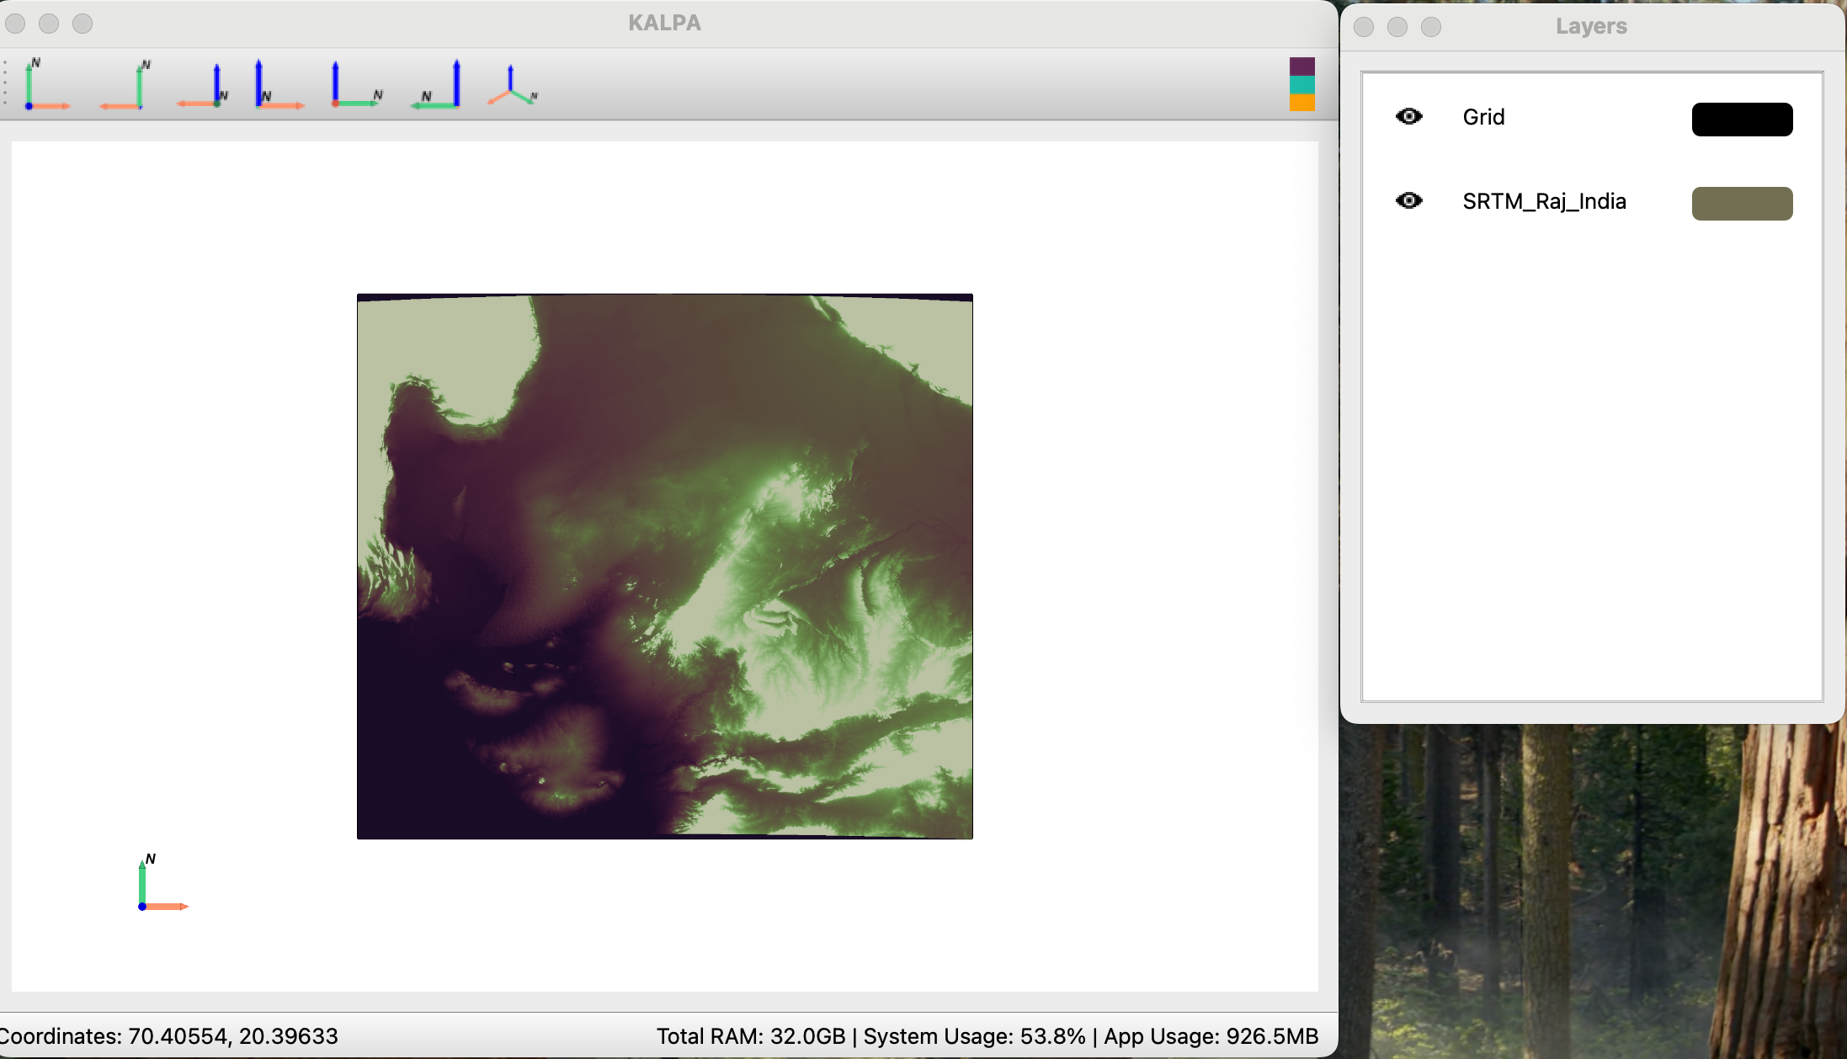

1. To visualise the legend. Click on the legend icon in the toolbar.

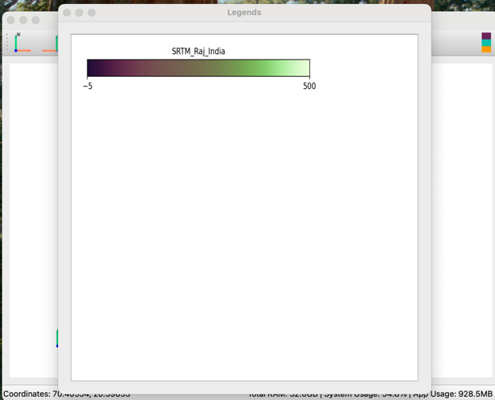

### Managing Layers

* Toggle the visibility of a layer using the **eye icon** next to the layer name.

### Customizing Layer Properties

1. Click the **colored rectangle** next to the layer name in the **Layer Window** to open the settings.



1. Configure the following properties:

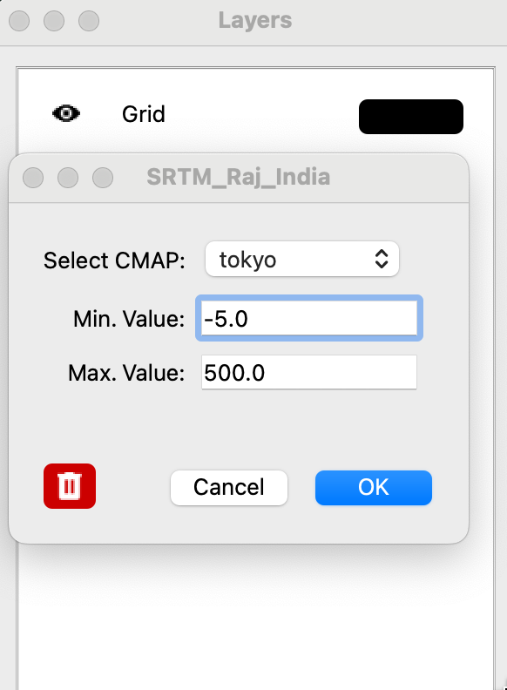

#### **Color Maps (cmaps)**

* Kalpa supports over 50 colormaps, including those from **matplotlib** and **Crameri's scientific colormaps**.
* Example colormaps:
  + Sequential: 'viridis', 'plasma', 'magma', etc.
  + Diverging: 'coolwarm', 'seismic', etc.
  + Scientific: 'batlow', 'roma', 'berlin', etc.

#### **Data Range**

* By default, the colormap range is set to the minimum and maximum values of the dataset.
* You can manually specify the minimum and maximum values for better control over the visualization.

## Loading and Configuring Vector Data

### Loading Vector Data

1. Navigate to **File > Vector**.
2. Select one or more .shp or .gpkg files (hold **Shift** for multiple selections) and click **Open**.
3. The **Layer Window** will display the loaded vector layers.

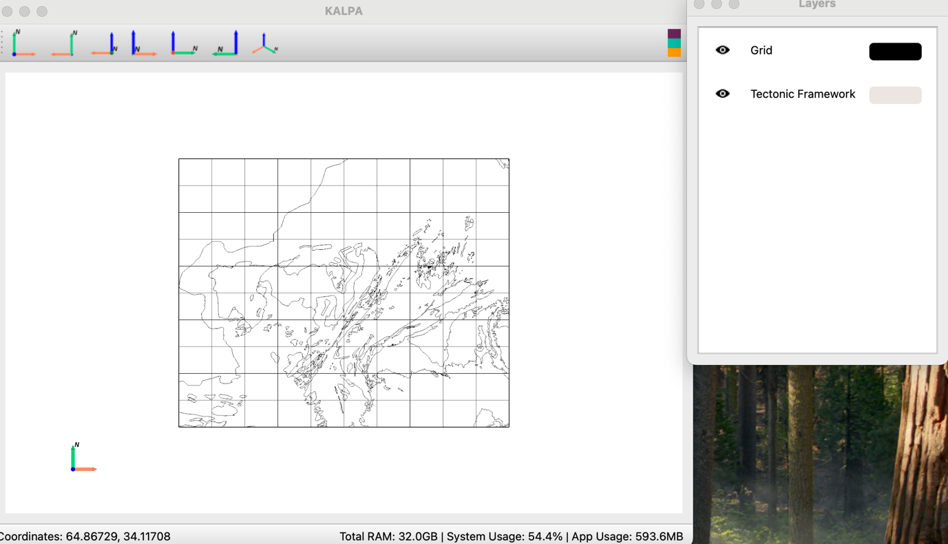

### Managing Layers

* Toggle the visibility of a layer using the **eye icon** next to the layer name.

### Customizing Layer Properties

1. Click the **colored rectangle** next to the layer name in the **Layer Window** to open the settings.

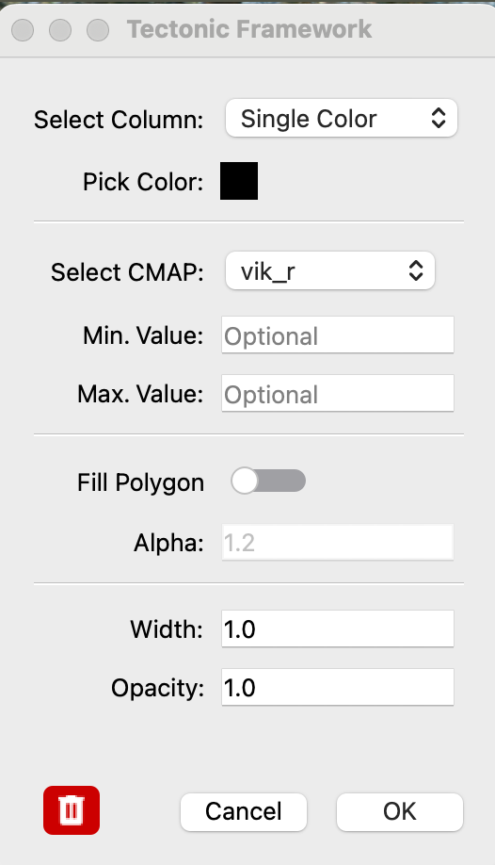

1. Configure the following properties:

#### **Geometry Display**

* By default, geometries are displayed in a single color. Use the **color picker** to change the outline color.

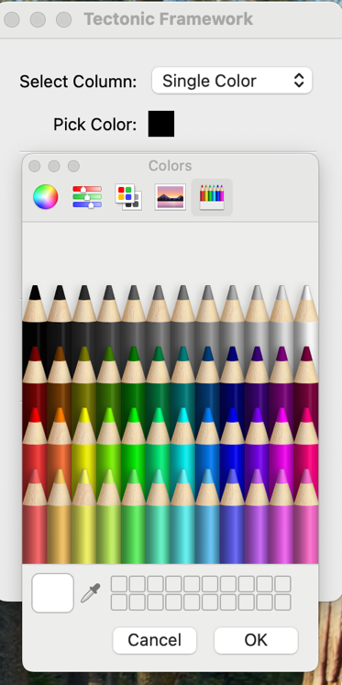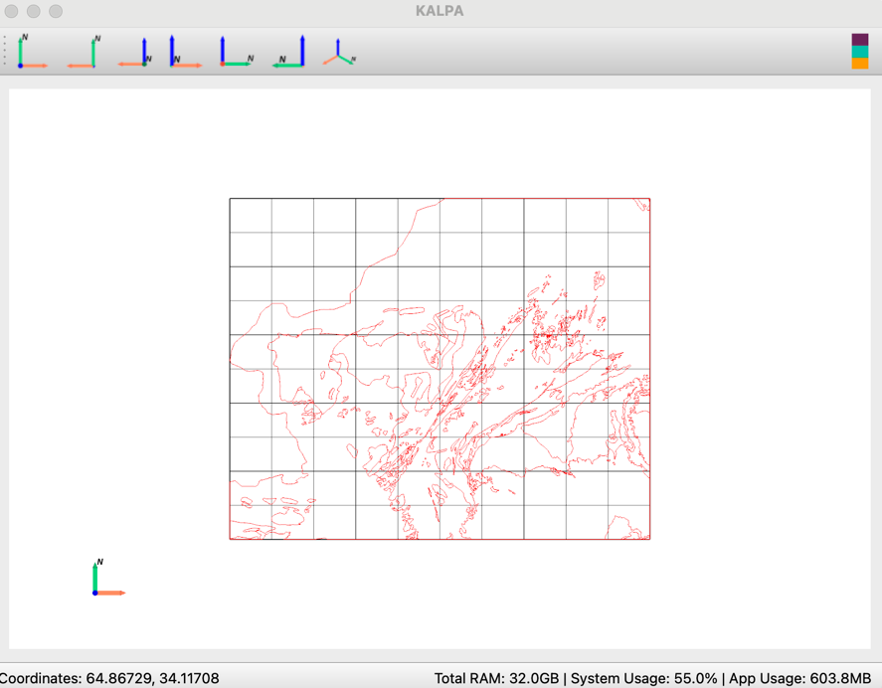

#### **Attribute-Based Coloring**

* Select a column from the vector data's attribute table to activate colormap-based visualization.
* Assign different colormaps or ranges to represent specific attributes.

#### **Fill Options**

* Choose between filling the geometry outline with a single color or using a colormap.

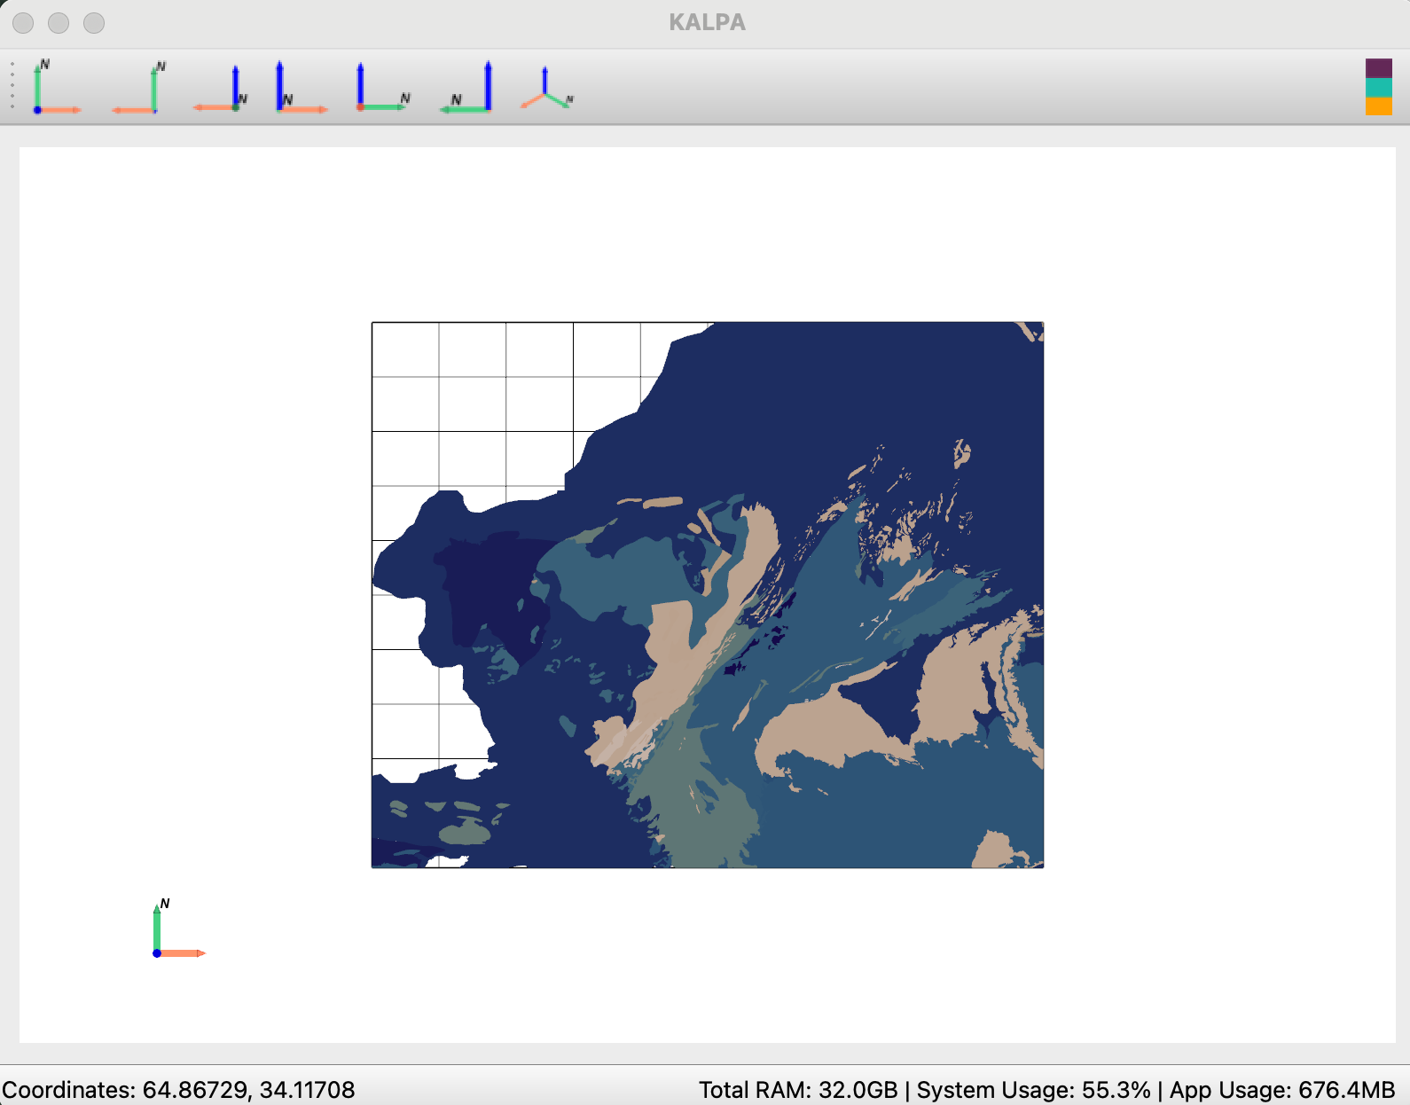

#### **Size and Opacity**

* Adjust the size/width and opacity of the geometries for better visualization.

Legends:

* To visualise legend or label, click on legend icon.

## Future Features

### Time-Dependent Data

* **Raster and Vector Data:** Enhanced functionality for visualizing and analyzing time-dependent geospatial datasets.

### Volume Raster Data

* Support for volumetric raster data will be introduced, enabling 3D visualization of subsurface features.

### Time-Dependent Volume Raster

* Upcoming versions will include the ability to handle dynamic volumetric data.

This chapter gives you a comprehensive understanding of loading and visualizing data in Kalpa. In the next chapter, we’ll explore controlling the view and saving figure.

# Grid Settings and View Controls

Kalpa includes robust grid settings and visualization controls to enhance data exploration and presentation.

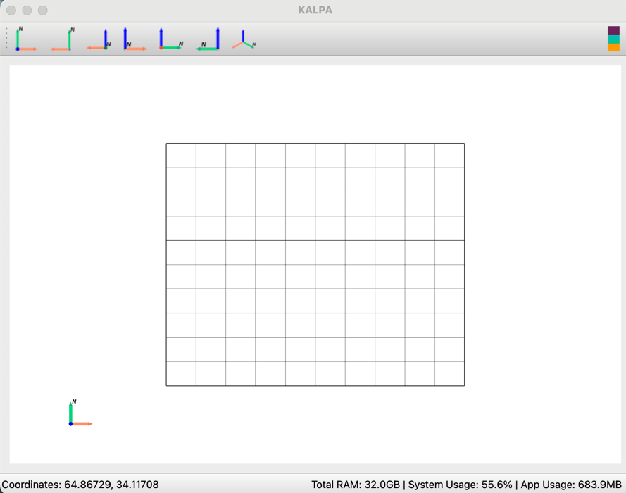

## Grid Settings

### Default Behaviour

* When Kalpa opens, a default global grid is loaded.
  + **Longitude:** Extends from -180° to 180° in 10° increments.
  + **Latitude:** Extends from -90° to 90° in 10° increments.
* Upon loading a dataset, the grid automatically adjusts to match the dataset's spatial extent.

### Customizing the Grid

To modify grid settings:

1. Open the **Layer Window**.
2. Click the **colored rectangle** next to the “Grid” Layer to access grid properties.

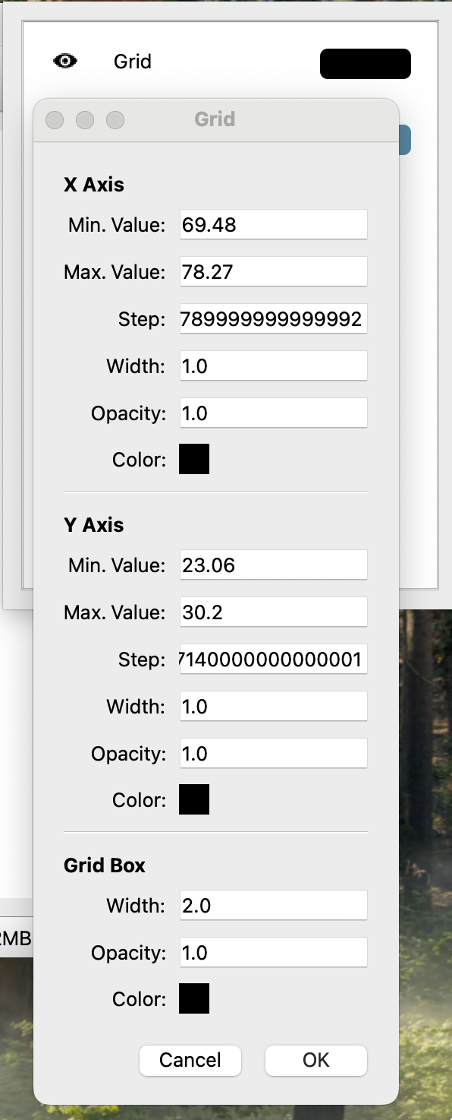

#### Adjustable Parameters

You can configure the following:

* **Grid Extents:** Minimum and maximum values for both axes.
* **Step Size:** Interval between grid lines.
* **Grid Line Appearance:** Set the line width, opacity, and color for both the x-axis and y-axis.
* **Grid Box Appearance:** Adjust the color, width, and opacity of the grid bounding box.

### Toggling the Grid

* To hide the grid, click the **eye icon** next to the “Grid” Layer in the **Layer Window**.

## Controlling the View

Kalpa allows intuitive control of the view using the mouse or touchpad. Below are the controls for zooming, rotating, and repositioning on both Windows and macOS:

### Zooming

* **Windows:** Scroll the **mouse wheel** up or down to zoom in and out.
* **macOS:** Use a **two-finger swipe** on the touchpad to zoom in or out.

### Rotating

* **Windows:**
  + **Left Mouse Button (LMB):** Click and drag to rotate the view.
  + Hold **Shift + LMB** to rotate along specific axes.
* **macOS:**
  + **Single Finger Drag:** Use one finger on the touchpad to rotate.
  + Hold **Shift + Drag** to constrain rotation to specific axes.

### Repositioning

* **Windows:**
  + **Right Mouse Button (RMB):** Click and drag to reposition the view.
  + Hold **Shift + RMB** for finer adjustments.
* **macOS:**
  + **Two-Finger Drag:** Use two fingers on the touchpad to reposition.
  + Hold **Shift + Two-Finger Drag** for precise movements.

### Resetting the View

* Press **R** to reset the view to its default orientation and zoom level.

## Saving Figures

Kalpa allows you to export visualized data in several formats for publication or presentation purposes.

### Supported Formats

* Vector Graphics: .svg, .eps, .ps, .pdf, .tex
* Raster Graphics: .png, .jpeg, .jpg

### Saving Procedure

1. Navigate to **File > Save Figure**.
2. Enter a **filename** and select the desired file **extension**.
3. Click **Save** to export the figure.

This chapter equips you with the tools to configure grid settings and effectively navigate your data in Kalpa. Whether you’re exploring datasets interactively or exporting high-quality visuals, Kalpa’s intuitive interface simplifies the process.

# Creating Data for Geodata Engineering and Artificial Intelligence Modeling

Kalpa makes it easy to prepare datasets for geodata engineering, geostatistics, and machine learning applications. By extracting information from loaded raster and vector layers, you can create structured, machine-trainable datasets tailored to your specific modeling needs. This chapter outlines how to filter, process, and extract data seamlessly.

## Overview

When you load multiple layers of raster and vector data, Kalpa allows you to extract their attributes for further analysis. This process involves creating a grid over a defined area of interest (AOI) and sampling raster values or vector attributes into a new dataset. The sampled data is saved as a vector file (.gpkg) and includes:

* **Raster Values:** Directly sampled at grid points.
* **Vector Attributes:** Selected columns from vector data and their distances to grid points.

For example, if you select a vector column named Fault_Age, the new layer will contain:

* A column named Fault_Age, which stores the sampled attribute value.
* A column named Fault_Age_dist, which stores the distance from the grid point to the nearest vector geometry.

## Grid Types for Data Sampling

Kalpa supports two primary gridding approaches to structure the sampling process:

### 1. **Random Grid**

* **Description:** Randomly distributes points across the AOI.
* **Applications:**
  + Suitable for creating unbiased training datasets for machine learning models.
  + Reduces spatial autocorrelation in training data, improving generalization.
* **Benefits:**
  + Provides diverse sampling across the area.
  + Reduces overrepresentation of specific regions or patterns.

### 2. **Regular Grid**

* **Description:** Creates a grid with uniform spacing based on a specified resolution.
* **Applications:**
  + Ideal for geodata engineering tasks, such as image processing or geophysical filtering (e.g., upward and downward continuation).
  + Useful for spatial modeling and interpolation.
* **Benefits:**
  + Ensures consistent coverage across the AOI.
  + Facilitates compatibility with raster-based algorithms.

For regular grids, the X and Y resolutions are identical, ensuring a uniform grid layout.

## Step-by-Step Guide: Sampling Data

### 1. **Accessing the Sampling Tool**

Navigate to **Data Processing > Data Sampling** to open the data sampling interface.

### 2. **Defining the Area of Interest (AOI)**

You must specify the region where the data will be sampled. You can define the AOI in two ways:

* **Bounding Box:**
  + Use the **Bounding Box Utility** to create a rectangular AOI based on an existing raster or vector layer.
  + Go to **Vector > Bounding Box**, select the layer, and save the bounding box layer.
* **Vector File:**
  + Use a vector file with complex polygon or multipolygon geometries, or point geometries, as the AOI.

### 3. **Selecting Data Layers**

* **Raster Layers:**  
  Select one or more loaded raster layers to sample values at grid points.
* **Vector Layers:**  
  Choose vector layers, and a dropdown with checkboxes will appear. You can select specific columns (attributes) from the vector data for sampling.

### 4. **Choosing a Gridding Method**

Select one of the two available gridding methods:

* **Random Grid:** Specify the number of points to generate.
* **Regular Grid:** Set the resolution of the grid.

### 5. **Creating the Grid and Sampling Data**

1. Click **Create** to generate the grid and begin sampling data.
2. Wait for the process to complete. A progress bar or notification will indicate the status.

### 6. **Saving the Sampled Data**

After the sampling process finishes, a saving window will appear. You can specify the file name and save the output as a vector file (.gpkg).

This vector file will be added as new layer in the layer window.

## Tips for Effective Data Sampling

* For large datasets, consider using an AOI that reduces the sampling region to save computational resources and time.
* When working with machine learning models, using a **Random Grid** can help reduce sampling bias and improve model performance.
* For spatially dense geodata engineering tasks, use a **Regular Grid** with a resolution that matches the scale of your analysis.

# Filtering Data

In geospatial analysis, filtering vector data is a common task to refine datasets based on specific conditions. Kalpa offers a powerful and flexible filtering mechanism using Python's Pandas-style operations. This chapter demonstrates how to filter vector data using conditions on one or multiple columns, enabling you to create tailored datasets for your analysis.

## Vector Filtering

The VectorLayerFiltering function allows you to filter a vector layer or a file containing vector data (.gpkg/.shp) using custom conditions written in Python's Pandas-style operations. Below is a guide to using the function, followed by practical examples.

### Function Overview

The VectorLayerFiltering function applies a condition to filter rows in a vector dataset and returns the filtered result.

**Key Arguments:**

* A file path to a vector dataset or select a layer from (e.g., .gpkg, .shp).
* **filter_condition**: A Python condition for filtering rows. The condition uses the format:

row['column_name'] <condition> value

You can combine multiple conditions using logical operators like and, or, and not.

### Examples

#### **Single-Column Based Filtering**

You may want to filter data based on a condition applied to a single column. For instance:

* **Scenario:** Filter all rows where the Population column is greater than 1,000.
* **Condition String:** row['Population'] > 1000

#### **Multi-Column Based Filtering**

To filter based on multiple conditions across different columns, you can combine them using logical operators.

* **Scenario:** Filter rows where the Population is greater than 1,000 **and** the City starts with the letter 'C'.
* **Condition String:** row['Population'] > 1000 and row['City'].startswith('C')

#### **Filtering Using Equality Conditions**

* **Scenario:** Filter rows where the City column is equal to 'B'.
* **Condition String:** row['City'] == 'B'

#### **Combining Conditions with** or

* **Scenario:** Filter rows where the Population is less than 1,000 **or** the City starts with 'A'.
* **Condition String:** row['Population'] < 1000 or row['City'].startswith('A')

#### **Filtering by Distance (Geospatial Attributes)**

For spatial datasets, you might filter based on proximity to specific features. For example, filtering rows where the distance to a fault line is less than 5 km can be done by creating a column such as Fault_Dist and applying:

* **Condition String:** row['Fault_Dist'] < 5

#### **Filtering Rows with Numerical Ranges**

* **Scenario:** Filter rows where Population is between 500 and 1,500.
* **Condition String:** 500 <= row['Population'] <= 1500

#### **Filtering Rows Based on String Patterns**

* **Scenario:** Filter rows where the City name contains the letter 'a' (case-insensitive).
* **Condition String:** row['City'].str.contains('a', case=False)

#### **Filtering Rows with Missing or Null Values**

* **Scenario:** Filter rows where the geometry column is None (missing).
* **Condition String:** row['geometry'] is None

### ***Filtering Rows Based on Multiple Conditions (Advanced)***

* **Scenario:** Filter rows where Population is greater than 1,000, and the City does **not** start with 'A'.
* **Condition String:** "row['Population'] > 1000 and not row['City'].startswith('A')"

### ***Filtering Rows Using Custom Functions***

* **Scenario:** Use a custom function to filter rows where the City name length is greater than 1 character.
* **Condition String:** "len(row['City']) > 1"

### ***Filtering Geospatial Data by Attribute and Proximity***

* **Scenario:** Suppose a dataset contains a column Fault_Age and Fault_Dist. Filter rows where faults are older than 50 million years **and** within 10 km of the grid points.
* **Condition String:** "row['Fault_Age'] > 50 and row['Fault_Dist'] < 10"

### ***Filtering Using Logical OR Conditions***

* **Scenario:** Filter rows where the City is either 'A' or 'C'.
* **Condition String:** "row['City'] in ['A', 'C']"

### **Filtering by Area or Length Attributes**

For vector datasets with polygons or lines, you can filter by geometric properties such as area or length.

* **Scenario:** Filter polygons where the area is greater than 1,000 square meters.
* **Condition String:** "row['geometry'].area > 1000"
* **Scenario:** Filter line features where the length is less than 500 meters.
* **Condition String:** "row['geometry'].length < 500"

Top of Form

Bottom of Form

**Tips for Writing Filtering Conditions**

1. **Use Logical Operators:** Combine conditions with and, or, or not to create complex queries.
2. **Check Data Types:** Ensure your column data types match the condition. For example, numeric values should not be compared to strings.
3. **Handle Missing Values:** Use Pandas-style operations like row['column'].notnull() to filter out rows with missing data.
4. **Validate Columns:** Ensure the columns used in filtering exist in the dataset.
5. **Optimize Conditions:** Use simple, efficient conditions to avoid unnecessary computational overhead.
6. **Test Conditions:** Before applying complex filters, test them on a small subset of data to ensure correctness.
7. **Export Results:** Save filtered datasets for further analysis or visualization.

# **Vector Calculator**

The **Vector Calculator** feature in Kalpa allows you to perform advanced calculations on the columns of a vector dataset (GeoDataFrame) and save the results as a new column. This is particularly useful for geospatial data engineering, statistical analysis, and feature generation for machine learning.

Using the VectorLayerCalculator operation, you can define custom operations to compute new columns based on existing data in a vector layer. This chapter will guide you through the process of using the Vector Calculator, including practical examples.

## **How to Use the Vector Calculator**

To compute new columns in your vector data:

1. **Load the Dataset**: Ensure the vector dataset is loaded into Kalpa.
2. **Define the New Column Name**: Choose a descriptive name for the column to store the calculated values.
3. **Write the Operation Code**: Use Python expressions to define the calculation. For example:
   * "row['column1'] + row['column2']"
   * "row['column1'] * 1.5"
   * "len(row['city_name'])"
4. **Save the Result**

When using the GUI of Kalpa, you’ll be prompted with the following inputs:

1. **Select Layer**: Choose the vector layer to apply the calculation.
2. **New Column Name**: Specify the name of the column to store the result of the calculation.
3. **Condition**: Write the operation code (Python expression) defining how the new column will be computed.

#### **Examples**

**1. Basic Arithmetic Operation**  
Add two columns col1 and col2 to create a new column sum_col.

sum_col

row['col1'] + row['col2']

**2. Scaling a Column**  
Multiply a column value by a constant factor of 1.5.

scaled_value

row['value'] * 1.5

**3. String Length Calculation**  
Create a new column city_name_length with the length of strings in the city_name column.

city_name_length

len(row['city_name']

**4. Conditional Calculation**  
Create a new column high_population where the value is 1 if population > 1000, else 0.

high_population

1 if row['population'] > 1000 else 0)

**5. Combining String Values**  
Combine the city and state columns into a single location column.

Location

f\"{row['city']}, {row['state']}\”

**6. Calculating Distance to a Reference Point**  
Compute the distance of each geometry to a reference point (x, y).

distance_to_point

row['geometry'].distance(reference_point)

**7. Geometric Area Calculation**  
Calculate the area of each geometry (for polygons).

area

row['geometry'].area

**8. Custom Transformations**  
Apply a logarithmic transformation to a column value.

log_value

math.log(row['value'])

#### **Using the Results**

Once the calculations are complete, you can:

* Visualize the new column in Kalpa's interface.
* Use the updated vector for further geospatial or statistical analysis.
* Save the dataset as a GeoPackage file using Kalpa’s export options:

#### **Best Practices**

1. **Column Names:** Use descriptive names for new columns to make the dataset self-explanatory.
2. **Error Handling:** Check your expressions for syntax errors or invalid column references before applying.
3. **Performance:** Avoid overly complex calculations on large datasets to maintain performance.
4. **Documentation:** Keep track of all transformations for reproducibility.

### 

### **Advanced Geophysical and Image Processing Calculations in Kalpa MineX+**

In this section, we introduce complex equations commonly used in geophysical signal processing or image processing that you can implement directly in Kalpa's **Vector Calculator**. These calculations can help you derive meaningful attributes from your geospatial datasets, particularly for machine learning, geophysical modeling, or data visualization.

#### **1. Hilbert Transform (Instantaneous Amplitude)**

The Hilbert Transform is widely used in signal processing to compute the instantaneous amplitude of a signal.

**Condition (Python Expression):**

np.sqrt(row['signal']**2 + np.imag(np.fft.hilbert(row['signal']))**2)

**Example Use Case:**  
This is useful for analyzing the envelope of seismic signals or any oscillatory data.

#### **2. Gradient Magnitude Calculation**

Compute the gradient magnitude from spatial derivatives in the X and Y directions.

**Condition (Python Expression):**

np.sqrt(row['gradient_x']**2 + row['gradient_y']**2)

**Example Use Case:**  
Calculate the spatial rate of change, which is essential in edge detection for image processing or geophysical anomalies in data like gravity or magnetic fields.

#### **3. Laplacian Filter**

The Laplacian filter is used to detect regions of rapid intensity change, often used in image and signal processing.

**Condition (Python Expression):**

row['d2_dx2'] + row['d2_dy2']

**Example Use Case:**  
Identify high-curvature zones in geophysical maps, such as subsurface density contrasts.

#### **4. Bandpass Filtering**

Apply a simple bandpass filter to retain features within a specific frequency range.

**Condition (Python Expression):**

low_cutoff <= row['frequency'] <= high_cutoff

**Example Use Case:**  
Filter seismic or geophysical signals to focus on features of interest, e.g., certain wave types or geological layers.

#### **5. Normalized Difference Index (NDI)**

A normalized ratio of two variables, commonly used in remote sensing (e.g., NDVI).

**Condition (Python Expression):**

(row['variable1'] - row['variable2']) / (row['variable1'] + row['variable2'])

**Example Use Case:**  
Analyze vegetation indices, water body detection, or other normalized geophysical relationships.

#### **6. Fourier Transform Coefficient Extraction**

Extract the real part of the first Fourier Transform coefficient for frequency-domain analysis.

**Condition (Python Expression):**

np.fft.fft(row['signal'])[0].real

**Example Use Case:**  
Identify dominant frequency components in geophysical signals.

#### **7. Directional Slope Calculation**

Compute the slope in a specific direction (e.g., northward).

**Condition (Python Expression):**

(row['z_north'] - row['z_center']) / row['distance_north']

**Example Use Case:**  
Analyze topographic or bathymetric gradients for hydrological modeling or structural geology.

#### **8. Gaussian Smoothing**

Apply Gaussian smoothing to a signal for noise reduction.

**Condition (Python Expression):**

np.exp(-0.5 * ((row['x'] - row['mean_x']) / row['std_dev_x'])**2)

**Example Use Case:**  
Smooth noisy geophysical data or enhance visualization of spatial datasets.

#### **9. Signal-to-Noise Ratio (SNR)**

Compute the SNR of a signal.

**Condition (Python Expression):**

10 * np.log10(row['signal_power'] / row['noise_power'])

**Example Use Case:**  
Evaluate the quality of geophysical signals for interpretation.

#### **10. Structural Similarity Index (SSIM)**

Calculate SSIM for image quality assessment in two columns (e.g., predicted vs. observed values).

**Condition (Python Expression):**

(2 * row['mean_x'] * row['mean_y'] + C1) * (2 * row['covariance'] + C2) / ((row['mean_x']**2 + row['mean_y']**2 + C1) * (row['var_x'] + row['var_y'] + C2))

**Example Use Case:**  
Compare geophysical or remote sensing images to identify changes or validate models.

### **Tips for Writing Complex Equations**

1. **Use Mathematical Libraries**: Leverage numpy for mathematical operations and scipy for advanced signal processing.
2. **Validate Columns**: Ensure the referenced columns exist in the dataset.
3. **Break Down Complex Calculations**: For readability, create intermediate columns for parts of the computation.

Top of Form

# How to apply machine learning in Kalpa?

## Tutorial 1: Classifying Lithology Types in the Ladakh Region Using Kalpa

This tutorial demonstrates how to classify lithology types in the Ladakh region using Kalpa. We will employ a supervised machine learning method, Random Forest, to train a model using satellite data and known lithology types. Once trained, this model will be used to predict lithology across the entire region.

### Dataset Overview

For this classification task, we use:

* **LANDSAT8 Bands**: Multispectral bands (1 to 8) as NetCDF files.
* **SRTM Elevation Data**: Elevation values from the Shuttle Radar Topography Mission (SRTM).

### Accessing the Dataset

The tutorial dataset is available [here](https://chatgpt.com/c/67725d7d-e0ac-8013-a6d3-2f9357f7c2ac).

### Workflow

#### Step 1: Load Raster Files

Start by loading the required raster datasets:

* All LANDSAT8 bands (Band 1 to Band 8).
* SRTM Elevation data.

#### Step 2: Load and Merge Label Files

Next, load the shapefiles containing known lithology types. These shapefiles represent 17 lithology classes, stored in the CLASS_NAME column:

* Alluvium
* Chert Jasper Metasediments
* Dunite
* Fluvial Channel
* Gabbro
* Ice
* Indus Formation
* Kargil Formation
* Ladakh Plutonic Complex
* Lake
* Lian
* Pyroxenite
* Serpentinized Peridotite
* Tso Morari Complex
* Volcanics
* Water
* Zildat Ophiolite Melange

Merge these shapefiles into a single GeoPackage file named All_Classes.gpkg using the "Merge Vector" functionality.

#### Step 3: Sample Training Data

Randomly sample the raster data (LANDSAT8 bands, SRTM Elevation) and lithology classes (CLASS_NAME) to create a training dataset. Select 100,000 data points and save the resulting file as Training_Dataset.gpkg.

#### Step 4: Build a Random Forest Classifier

**What is Random Forest?**

Random Forest is an ensemble learning method that operates by constructing multiple decision trees during training and outputs the mode of the classes for classification tasks. It is robust, handles high-dimensional data well, and is resistant to overfitting.

**Key Parameters:**

* n_estimators: Number of trees in the forest (e.g., 100).
* criterion: Function to measure split quality (e.g., "gini" for Gini impurity).
* max_depth: Maximum depth of a tree. None allows nodes to expand until pure.
* min_samples_split: Minimum samples required to split a node.
* min_samples_leaf: Minimum samples required at a leaf node.
* max_features: Number of features to consider for the best split (e.g., "sqrt").
* bootstrap: Whether bootstrap samples are used to build trees.

**Training the Model:**

1. Navigate to **Model → Random Forest Classifier → Create New Model**.
2. Load Training_Dataset.gpkg.
3. Set the training features (Band1 to Band8, SRTM Elevation).
4. Set the target feature (CLASS_NAME).
5. Configure the Random Forest parameters as needed.
6. Train the model and save it for future use.

#### Step 5: Predict Lithology for the Entire Region

##### Step 5.1: Prepare the Prediction Dataset

1. Define the area of interest using a bounding box or a shapefile.
2. Sample raster data at regular grid intervals. Exclude CLASS_NAME since it will be predicted.
3. Save the sampled dataset as Prediction_Dataset.gpkg.

##### Step 5.2: Perform Prediction

1. Navigate to **Models → Random Forest Classifier → Existing Model**.
2. Load the trained model.
3. Select Prediction_Dataset.gpkg for prediction.
4. Save and visualize the predicted lithology layer.

# Tutorial 2: Simple Mineral Prospectivity Maps with Kalpa

In this tutorial, we will use Kalpa to build a mineral prospectivity map. The process will utilize three types of datasets: geophysical data (e.g., Bouguer Gravity Anomaly, Magnetic Anomaly), geological data (e.g., geological age, folds, faults, lineaments), and satellite data (e.g., ASTER, SRTM, and LANDSAT). The goal is to create prospectivity maps for copper deposits based on the known occurrences of 96 mineral deposits in the study region.

We will first sample various datasets at the locations of known copper mineral occurrences. Then, we will create an unlabeled dataset to differentiate regions of interest. Using a Random Forest (RF) classifier, we will label the dataset and then employ an RF regressor to construct the prospectivity map.

## Dataset Overview

### Geophysical Data:

* **Gravity Data:**
  + Observed Gravity
  + Theoretical Gravity
  + Bouguer Anomaly
* **Magnetic Data:**
  + Observed Magnetism
  + IGRF
  + Magnetic Anomaly

### Geological Data:

* Tectonic Age
* Folds
* Faults
* Lineaments

### Satellite Data:

* **LANDSAT8 Bands:**
  + Multispectral bands (3 to 8) as NetCDF files
* **SRTM Elevation Data:**
  + Elevation values from the Shuttle Radar Topography Mission (SRTM)
* **ASTER Data:**
  + Multispectral bands (1 to 14) as NetCDF files

### Mineral Occurrences:

The dataset includes 96 known occurrences of mineral deposits. For this tutorial, we focus on copper deposits.

## Workflow

### Step 1: Loading Data and Visualization

1. **Start Kalpa** and choose Cartesian coordinates as the working coordinate system.
2. Create a new folder named "MineralProspectivity" to save the dataset, figures, etc.
3. **Import Raster Data:**
   * Go to File -> Import -> Raster and load the following:
     + SatelliteData/SRTM/SRTM_Raj_India.nc
     + SatelliteData/ASTER/Band_1_ASTER.nc to Band_14_ASTER.nc
     + SatelliteData/LANDSAT/Band_3_LANDSAT.nc to Band_8_LANDSAT.nc
   * Adjust the colormap (cmap) and range as needed.
4. **Import Vector Data:**
   * Go to File -> Import -> Vector and load the following:
     + ShapeFiles/Fault_Tectonic.shp
     + ShapeFiles/Fold_Tectonic.shp
     + ShapeFiles/Lineament_Tectonic.shp
     + ShapeFiles/Tectonic_Framework.shp
     + GeophysicalData/Gravity.shp
     + GeophysicalData/Magnetic.shp
     + Deposits/Deposits.shp
5. **Customize Visualization:**
   * Adjust the color and width of line elements (Faults, Folds, and Lineaments).
   * For ShapeFiles/Tectonic_Framework.shp, set the column to AGE and apply a suitable colormap.
   * For Gravity.shp and Magnetic.shp, set the column to BOUGUER_AN and MAGNETIC_A, respectively. Apply diverging colormaps and set the range. Note that some datasets may have NaN values (appearing as the same color), which will be addressed in the next step.
   * For Deposits/Deposits.shp, increase the point size for visibility.

### Step 2: Processing and Filtering Data

1. **Filter Out NaN Values:**
   * Go to Data Processing -> Vector -> Filtering.
   * Select the layer (e.g., Gravity) and use the condition: pd.notna(row['BOUGUER_AN']).
   * Save the filtered dataset as gravity_filtered.gpkg. The filtered layer will load automatically.
   * Repeat for Magnetic data with the condition: pd.notna(row['MAGNETIC_A']).
2. **Filter Copper Deposits:**
   * Select the Deposits layer and apply the condition:
   * 'Cu' in row['MINERAL_OR']

### Step 3: Extract Data at Known Occurrences

1. **Sample Data:**
   * Go to Data Processing -> Data Sampling.
   * Select Deposits.shp as the area of interest.
   * Choose layers and columns to sample:
     + **Gravity:** Observed_G, Theoretical_G, BOUGUER_AN
     + **Magnetic:** Observed_M, IGRF, MAGNETIC_A
     + **Folds, Faults, Lineaments:** Select any column to generate distance columns (column_name_cdist).
   * Add a new column LABEL using the Vector Calculator and assign it a value of 1 (positive label).
   * Save as Sampled_Deposit_with_Label.

### Step 4: Create Unlabeled Data

1. **Generate Bounding Box and Random Points:**
   * Use Kalpa’s Bounding Box utility to create a bounding box for the study area.
   * Generate random points within the bounding box and sample the data as in Step 3.
2. **Filter Points Based on Proximity:**
   * Use the column BOUGUER_AN_cdist to filter points beyond a reasonable distance (e.g., row['BOUGUER_AN_cdist'] < 0.01).
   * Assign a LABEL of 0 to these points.
   * Save as Sampled_Unlabelled_Points.

### Step 5: Build Random Forest Classifier

1. **Prepare Data for Training:**
   * Merge positive samples (Sampled_Deposit_with_Label) and unlabeled samples (Sampled_Unlabelled_Points) using Data Processing -> Vector -> Merge Layer.
   * Save the result as PU_Data.
2. **Train RF Classifier:**
   * Go to Models -> Random Forest Classifier -> Create New Model.
   * Use PU_Data.gpkg as the training dataset, with LABEL as the target feature.
   * Select all available features (excluding geometry) and adjust RF parameters.
   * Train and save the model.

### Step 6: Filter Negative Samples

1. **Predict Labels:**
   * Load the trained RF model and apply it to PU_Data.gpkg.
   * Save the predictions as PU_Prediction.gpkg.
2. **Filter Negative Samples:**
   * Use the condition row['Predicted_LABEL'] < 0.05 to identify negative samples.
   * Assign a LABEL_Pros value of -1 and save as Negative_Sample_with_Label.

### Step 7: Build Prospectivity Model

1. **Merge Training Data:**
   * Ensure all necessary columns are present in both positive and negative samples.
   * Merge into Prospectivity_Training_Data.
2. **Train RF Regressor:**
   * Use Prospectivity_Training_Data to train an RF regressor.
   * Save the trained model as Prospector.

### Step 8: Generate Prospectivity Map

1. **Prepare Data:**
   * Create a regular grid and sample data as in Step 3.
   * Save as AOI_whole_region.
2. **Predict Prospectivity:**
   * Load the Prospector model and apply it to AOI_whole_region.gpkg.
   * Save the output as Prospectivity_Maps.
3. **Visualize:**
   * In the Layer window, select the column Predicted_LABEL_Pros to display the prospectivity map.

Bottom of Form